**Chapter 1**

**Introduction**

**Rationale**

Information portals are web-based platforms that serve as gateways to a variety of information and services. They are designed to provide users with easy access to relevant information, applications, and tools. Portals can be general-purpose, providing access to a wide range of information, or specialized, focusing on specific topics or industries. Such portals are designed with aesthetically pleasing user interfaces that offer many easy to use core features and cost-effective solutions. With elements such as a learning management system, news, notices, and real-time notifications, the educational portals provide a central point of communication between students, teachers and admins.

**Objectives**

* Information portal management system (IPMS) focuses on the basics of setting up and managing an effective information portal, providing key insights and strategies for maximizing its functionality and usefulness.
* It is a web-based platform that provides users with access to a variety of information, resources, and services. These systems are designed to organize and present information in a way that is easy to navigate and search.
* These systems typically provide tools for organizing content, managing user access, and customizing the portal's appearance and functionality.

**Web-based System**

* Allow users to access the portal from any web browser.
* Provide a dashboard for administrators to manage content, users, and permissions.
* Enable users to search for information using keywords, filters, and categories.
* Support multimedia content such as text, images, videos, and documents.
* Offer collaboration tools like discussion forums, chat, and notifications.
* Ensure responsive design for seamless access on different devices.

**Scope and Limitations**

Information portals have evolved significantly over the years. In the early days of the internet, portals primarily served as gateway sites that aggregated links to other websites. However, with advances in technology, portals have become more sophisticated, offering personalized content, social media integration, and advanced search capabilities.

Despite their benefits, information portals also present several challenges. These include ensuring the accuracy and relevance of information, managing user access and permissions, and integrating data from various sources. Additionally, portals must be regularly updated to keep pace with changing user needs and technological advancements.

**CEC School**

* Effective information portal management can lead to several benefits for school, including improved productivity, enhanced collaboration, and better decision-making.
* By providing easy access to information, portals can help organizations streamline their operations and achieve their business goals more efficiently.

**Web-based System what could do (ADMIN):**

* User Management
* Security
* Analytics
* Maintenance and Support

**Web-based System what could do (STAFF):**

* Classroom Management
* Communication
* Assessment and Grading
* Attendance Tracking
* Analytics and Reporting
* Security and Privacy

**Web-based System what could do (USER):**

* Inquiry
* Accessing Information
* Searching and Browsing
* Viewing and Reading
* Interacting with Content
* Personalization

**Significance of the Project**

An information portal typically consists of several key components, including a user interface, content management system, search engine, and security features. The user interface is designed to be intuitive and user-friendly, allowing users to easily navigate the portal and find the information they need. The content management system allows administrators to create, edit, and manage content on the portal. The search engine enables users to quickly find specific information, while security features protect sensitive information from unauthorized access.

**CHAPTER 2**

**REVIEW OF RELATED LITERATURE AND STUDIES**

**RELATED LITERATURE**

(Gunathilake, Indrathilake, & Wedagedera, 2009) proposed an opensource web based MIS for the University of Ruhuna, Sri Lanka. This they were able to implement with the LAMP/WAMP technologies. They were able to categorize their users based on administrator, super admin, top admin, general, lecturer and student. The pilot version was targeted at their Faculty of Science and they achieved a password encryption with the primary DES algorithm. 19

(Mariusz , 2010) in his solution University Study-Oriented System (USOS) in Poland stated that the main functional parts are the admin, web, admission/registration of students, database of results, course and diploma catalog, statistics etc. According to him, this solution is used by 27 higher education Polish institutions. In such a system, before transferring any module for production use it has to pass through sample database and university test. Documentation comprising system specification and implementation were updated regularly. Such solutions enhance communication between students and lecturers, proper security measures to prevent against Cross-site request forgery.

(Bharaagoudar, Geeta, & Totad, 2013) developed a web-based Student Information Management System in India which could send emails to students to validate their mailbox on registration. They were able to achieve this using technology such as HTML, CSS, Javascript, PHP and SQL. According to their description, it is a paperless work that assists in automating existing manual methods and can be remotely monitored and controlled on a server based network, the SIMS developed had no built-in security measures to prevent SQL injection.

(Hemn & Wu , 2014) proposed a system in China that can provide students’ general and educational information. According to them, the Students Information Management System (SIMS) can be used to create, read and update the details of a student and also generate reports about his/her skills and experience. Such systems save time of retrieval and prevent data loss.

An Information System (IS) can be any organized combination of people, hardware, software, communications networks, data resources, policies and procedures that stores, retrieves, transforms and disseminates information in an organization. (O'Brien & Marakas, 2011).

(Pinho et al. and Saghapour et al.) refer that web portals have revolutionized the way the academic community interacts and communicates [3,4]. Pinho et al. and Bawack and Kamdjoug argue that this technology enables the integration of all the institutional information, applications, and tools into a single system, thereby facilitating the procedures and changing the way of communicating, the working relationships, and the teaching and learning activities [3,5]. As mentioned by Pinho et al., the resistance to the implementation of these web tools can make information management and success of the HEIs increasingly difficult, i.e., the acceptance of the technology is fundamental for the successful use of these platforms [3].

Providing the best education to children is vital for their overall growth and development. As a result, parents take their time to know everything about the schools they have shortlisted for their child. They visit school websites and look for relevant testimonials before enrolling their kid in any school. A school website is crucial as it is the first point of interaction between schools and parents. That’s why schools need an impressive website with all relevant information to attract the attention of parents and potential students. The website for schools is a mirror for the school management as it affects their overall image and reputation. An impressive website containing relevant information is vital to increase the number of admissions to the educational institution ([DIVYANSH BORDIA](https://blog.teachmint.com/author/divyansh/), 2022).

Online education has transformed the way we approach learning, offering convenience, flexibility, and access to education for people from all walks of life. It has become a popular option for students of all ages, with online courses available from some of the world's top universities, covering a range of subjects and fields. However, with the widespread adoption of online education, there has been an ongoing debate about its impact on learning outcomes.

One of the main advantages of online education is the flexibility it offers. Students can access course materials and lectures at their convenience, and they can learn at their own pace. This means that people with busy schedules, such as working adults or parents, can fit education into their lives in a way that suits them. Online education also removes geographical barriers, allowing students from around the world to access courses from anywhere with an internet connection (Valentine Ubah, 2023).

Nowadays, technological advances in providing transformations in the school scenario, and one of them are the drastic change in secondary school management during the digital era. The purposes of this research were 1) to study the current situations and problems of secondary school management during the digital era; 2) to study the scenarios of secondary school management during the digital era in the next decade (2022-2031). The research specifically looked into 4 core missions of secondary school: 1) management of teaching and learning 2) personnel management 3) budgeting and 4) educational management. The research was conducted in 2 phases. Phase I: studying the current situations and the problems of secondary school management during the digital era by using a questionnaire to collect data from a sample group of 230 secondary school administrators. Phase II: studying the scenarios of secondary school management during the digital era in the next decade (2022-2031) using Ethnographic Delphi Futures Research (EDFR) for 3 parts. Part 1: Interviewing 19 experts using a semi-structured interview form and then analyzing and synthesizing the future tenders (scenarios). Part 2: Assessing the feasibility and the appropriateness of the scenarios by using a 5-level scale questionnaire. The statistics used were median and interquartile range. Part 3: Confirm trend scenarios of secondary school management during the digital era in the next decade (2022-2031). The findings revealed that the current situations of practice are all at a high level and the problems of the management are all at a moderate level. The scenarios of secondary school management during the digital era in the next decade (2022-2031) consist of 4 key elements and 40 possible trends, namely: 1) management of teaching and learning in the digital era with 15 possible trends; 2) educational personnel in the digital era with 10 possible trends; 3) budget in the digital era with 6 possible trends; and 4) educational management in the digital era with 9 possible trends (Thasai, Sakdadach; Sirisuthi, Chaiyuth; Aksornsua, Pha, 2023).

(Tubin, Dorit; Klein, Sarit 2007) Over the past few years, as part of the Information and Communication Technology (ICT) reform on the one hand, and the increased demands for school accountability on the other, more and more schools have launched a school website aimed at enhancing educational activities, supporting student-teacher communication, contributing to school marketing efforts, and fostering accountability to and collaboration with the school's constituency. A large body of research on ICT-based pedagogical and educational websites reveals the contributions of such websites to the schooling process. However, the phenomenon of school websites, which serve the school organization in its entirety, remains relatively unexplored. In this study, the authors explore the contents and structure of school websites and their responsiveness to their school's environment. They briefly review the literature regarding school websites, describe the institutional theory that provides the conceptual framework for the study, present the study methods and findings, and finally discuss the results and suggest practical implications for accountability-oriented school website development.

Management information systems (MIS) programs were developed to prepare graduates to create innovative solutions to problems where business and technology intersect. As such, the curricula must change rapidly to stay current with industry standards, an accelerating moving target. This research presents the findings of a systematic literature review to identify and present trends in the scholarly literature on MIS education. The purpose of this approach was to understand how academia ensures students are prepared for industry and keeps pace with changing industry needs. Key findings from the literature are presented, as well as a compilation of areas for future research. Overwhelmingly, a lack of international perspective was identified as the vast majority of articles collected data in the US. Further, the direction of future research and exploration revolved around five themes of innovative pedagogical approaches, industry partnerships, subtopics of MIS education, new methods and metrics for measuring success in MIS education, and cross-disciplinary opportunities in fields such as mathematics, traditional business disciplines, and the hard sciences (Elrod, Cassandra C.; Stanley, Sarah M.; Cudney, Elizabeth A.; Hilgers, Michael G.; Graham, Cameron , 2022).

**RELATED STUDIES**

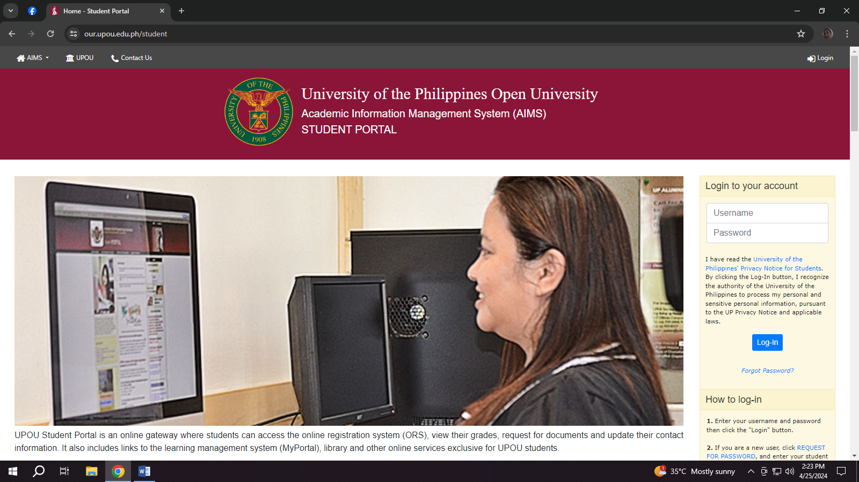This chapter discuss the history and state of the art of the web, web applications and web application vulnerabilities, also relevant literatures were review under the domain of information system security and web application security.

Figure 2.1 : [University of the Philippines Open University (our.upou.edu.ph/student)](https://www.topservelms.com/)

The University of the Philippines Open University (UPOU) website plays a vital role in supporting the university's mission to provide equitable access to quality higher education through open and distance learning modalities.

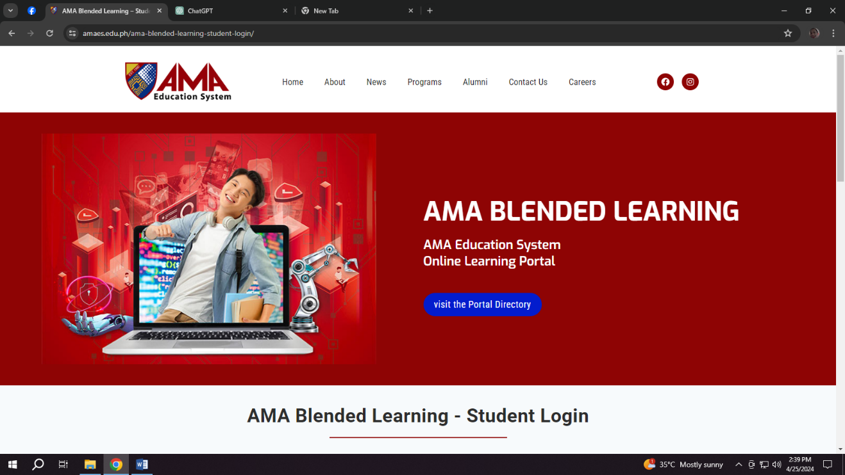

Figure 2.1 : AMA Education System (https://www.amaes.edu.ph/)

The AMA Education System's online learning portal serves as a dynamic platform for delivering high-quality education, fostering student engagement and collaboration, and supporting student success in their academic pursuits..

**CHAPTER 3**

**TECHNICAL BACKGROUND**

**TECHNICALITY OF THE PROJECT**

The proponents have used web-based program wherein the users can access it

The proponents have used web-based program wherein the users can access it

The proponents have used web-based program wherein the users can accessit through any digital platforms. The Information portal management system is an online portal for easy and convenient access by students and staff without using the traditional process communicate with teachers. These are some of the technical terms that are being used in our project: VS Code ­­– Text editor, PHP, HTML, CSS, Apache, DATABASE – Server-client side, Xampp, Javascript – Functionality. Some of the terminologies being stated above are also the technology being used in our project.

**DETAILS OF THE TECHNOLOGY TO BE USED**



Figure 3.3: HTML

HTML stands for hypertext markup language. It’s made of keywords and commands that web designers use for creating websites. Hypertext is text with links that readers can simply click on to go to another page or another part of the page. Meanwhile, markup language uses tags or plain text with special markings to define the sections of a page, such as headers and footers, and other elements, including tables and images.

Figure 3.4: CSS

Cascading Style Sheets, fondly referred to as CSS, is a simple design language intended to simplify the process of making web pages presentable handles the look and feel part of a web page. Using CSS, you can control the color of the text, the style of fonts, the spacing between paragraphs, how columns are sized and laid out, what background images or colors are used, layout designs, variations in display for different devices and screen sizes as well as a variety of other effects.



Figure 3.5: JAVASCRIPT

Web development frequently uses JavaScript, a flexible programming language. It makes websites capable of displaying dynamic content, including interactive elements like form validation, animations, and real-time updates without requiring a page refresh. It makes it easier for users to engage with the LMIS through search searches, form submissions, and real-time updates.



Figure 3.6: MYSQL

MySQL is an open-source relational database management system (RDBMS) that handles data administration and manipulation tasks using Structured Query Language (SQL). Many developers and businesses choose MySQL because of its reputation for dependability, scalability, and user-friendliness. It works effectively for handling user accounts, transactional records, and library catalogs in the LMS.

Figure 3.7: VISUAL STUDIO CODE

****Microsoft created Visual Studio Code (VS Code), a free source-code editor for Windows, Linux, and macOS. Code completion, syntax highlighting, debugging, and a number of other enhancements that improve its usefulness for various programming languages and development jobs are supported. Developers use it extensively to write code in many different languages, including JavaScript, Python, Java, and many more. It increases output and makes code optimization and debugging easier for the LMS development process.

Figure 3.9: PHPMYADMIN

MySQL and MariaDB database management can be done with PHPMyAdmin, a free and open-source web-based administration tool. Using an intuitive graphical interface, users may create, delete, change, and query databases, tables, and records, among other database activities, instead of utilizing a command-line interface. Database managers and web developers utilize it extensively to effectively manage their systems. Developers working on the LMIS may better interface with the database and avoid writing complex SQL queries by using PHPMyAdmin, which streamlines database management duties.



Figure 3.9: GOOGLE

Google Chrome browser is a free web browser used for accessing the internet and running web-based applications. The Google Chrome browser is based on the Open Source Chromium web browser project. Google released Chrome in 2008 and issues several updates a year.

**CHAPTER 4**

**Methodology**

The objective clarification phase of the CEC Information Portal Management System (CECIPMS) focuses on defining its purpose and scope, emphasizing the establishment of an effective information portal. This involves delineating the goals of providing key insights and strategies aimed at maximizing the functionality and usefulness of the portal. Subsequently, in the requirements analysis stage, stakeholder interviews and workshops are conducted to grasp user needs and organizational objectives. Essential features and functionalities necessary for an effective information portal, such as content organization, user access management, and customization options, are identifiedThe chosen platform should offer robust tools for organizing content, managing user access, and customizing the portal's appearance and functionality. In system design, a comprehensive architectural blueprint is developed, outlining the necessary structure and components for efficient information management. This includes designing user-friendly interfaces and navigation structures to ensure ease of use and accessibility. Content organization strategies are then defined to categorize information and resources logically, supplemented by tools for tagging, metadata management, and content indexing to enhance searchability and discoverability.

User access management is prioritized, with the implementation of robust authentication and authorization mechanisms to ensure secure access, along with defining user roles and permissions based on responsibilities. Customization and personalization features are integrated to cater to the diverse needs of user groups, allowing for tailored experiences. Comprehensive training materials and ongoing support are provided to aid users in effectively utilizing the CECIPMS. Monitoring tools and analytics are employed to track usage patterns, user feedback, and system performance, driving continuous optimization and improvement efforts. A culture of continuous improvement is fostered through feedback solicitation from users and stakeholders, leading to regular reviews and updates of the portal's features, content, and functionality. In conclusion, this methodology ensures a structured approach to setting up and managing an effective information portal, with a strong emphasis on maximizing functionality and usefulness within the framework of the CECIPMS, while highlighting the significance of ongoing monitoring, optimization, and continuous improvement to align with organizational goals.

**POPULATION OF THE STUDY**

|  |  |  |
| --- | --- | --- |
|  | POPULATION | SAMPLE |
| RESPONDENTS | CEC | CEC |
| Staff | 60 | 10 |
| User | 1000 | 300 |
| Admin | 1 | 1 |
|  |  |  |
| TOTAL | 1061 | 311 |

Figure 4.0

**GANNT CHART**

|  |  |  |  |  |  |  |  |  |  |  |  |  |  |  |  |  |  |  |  |
| --- | --- | --- | --- | --- | --- | --- | --- | --- | --- | --- | --- | --- | --- | --- | --- | --- | --- | --- | --- |
|  | Task Name | Duration | Start | End | Feb 9 – March 8 | | | | | March 9 –  March 22 | | | | | March 23 – April 20 | | | | |
|  |  |  |  |  | F | S | F | S | F | S | F | S | F | S | F | S | F | S | F | |
| 1 | Information Portal Management System | 106 days | 02/16/24 | 05/20/24 |  | | | | | | | | | | | | | | | |
|  |  |  |  |  |  | | | | | | | | | | | |  |  |  | |
|  |  |  |  |  |  |  |  |  |  |  |  |  |  |  |  |  |  |  |  | |
| 2 | 1. **Introduction** | 17 days | 02/16/24 | 03/04/24 |  | | |  |  |  |  |  |  |  |  |  |  |  |  | |
|  |  |  |  |  |  | | |  |  |  |  |  |  |  |  |  |  |  |  | |
|  |  |  |  |  |  |  |  |  |  |  |  |  |  |  |  |  |  |  |  | |
| 3 | 1.1 Rationale | 3 day | 02/16/24 | 02/19/24 |  | | | |  |  |  |  |  |  |  |  |  |  |  | |
|  |  |  |  |  |  |  | | |  |  |  |  |  |  |  |  |  |  |  | |
|  |  |  |  |  |  |  |  |  |  |  |  |  |  |  |  |  |  |  |  | |
| 4 | 1.2 Objectives | 3 day | 02/16/24 | 02/19/24 |  | | | |  |  |  |  |  |  |  |  |  |  |  | |
|  |  |  |  |  |  |  | | |  |  |  |  |  |  |  |  |  |  |  | |
|  |  |  |  |  |  |  |  |  |  |  |  |  |  |  |  |  |  |  |  | |
| 5 | 1.3 Scope and Limitations | 6 days | 02/22/24 | 02/28/24 |  |  | | |  |  |  |  |  |  |  |  |  |  |  | |
|  |  |  |  |  |  |  |  |  |  |  |  |  |  |  |  |  |  |  |  | |
|  |  |  |  |  |  |  |  |  |  |  |  |  |  |  |  |  |  |  |  | |
| 6 | 1.4 Significance of the Project | 5 days | 02/28/24 | 03/04/24 |  |  |  | | |  |  |  |  |  |  |  |  |  |  | |
|  |  |  |  |  |  |  |  | |  |  |  |  |  |  |  |  |  |  |  | |
|  |  |  |  |  |  |  |  |  |  |  |  |  |  |  |  |  |  |  |  | |
| 7 | 1. **Review of Related Literature and Studies** | 17 days | 03/02/24 | 03/15/24 |  |  |  | | | | | | |  |  |  |  |  |  | |
|  |  |  |  |  |  |  |  | | | | | | |  |  |  |  |  |  | |
|  |  |  |  |  |  |  |  |  |  |  |  |  |  |  |  |  |  |  |  | |
| 8 | 2.1 Review of Related Literature | 3 days | 03/15/24 | 03/18/24 |  |  |  |  |  |  |  | | |  |  |  |  |  |  | |
|  |  |  |  |  |  |  |  |  |  |  |  |  |  |  |  |  |  |  |  | |
|  |  |  |  |  |  |  |  |  |  |  |  |  |  |  |  |  |  |  |  | |
| 9 | 2.2 Related Studies | 3 days | 03/15/24 | 03/18/24 |  |  |  |  |  |  |  | | |  |  |  |  |  |  | |
|  |  |  |  |  |  |  |  |  |  |  |  |  |  |  |  |  |  |  |  | |
|  |  |  |  |  |  |  |  |  |  |  |  |  |  |  |  |  |  |  |  | |
| 10 | 1. **Technical Background** | 20 days | 03/27/24 | 04/05/24 |  |  |  |  |  |  |  |  |  |  |  | | |  |  | |
|  |  |  |  |  |  |  |  |  |  |  |  |  |  |  |  | | |  |  | |
|  |  |  |  |  |  |  |  |  |  |  |  |  |  |  |  |  |  |  |  | |
| 11 | 3.1 Technicality of the Project | 3 days | 04/01/24 | 04/04/24 |  |  |  |  |  |  |  |  |  |  |  |  |  |  |  | |
|  |  |  |  |  |  |  |  |  |  |  |  |  |  |  |  |  |  |  |  | |
|  |  |  |  |  |  |  |  |  |  |  |  |  |  |  |  |  |  |  |  | |
| 12 | 3.2 Details of the Technology to be Used | 5 days | 03/28/24 | 04/04/24 |  |  |  |  |  |  |  |  |  |  |  | |  |  |  | |
|  |  |  |  |  |  |  |  |  |  |  |  |  |  |  |  |  |  |  |  | |
|  |  |  |  |  |  |  |  |  |  |  |  |  |  |  |  |  |  |  |  | |
| 13 | 1. **Methodology** | 24 days | 03/23/24 | 04/05/24 |  |  |  |  |  |  |  |  |  |  |  | | |  |  | |
|  |  |  |  |  |  |  |  |  |  |  |  |  |  |  |  | | |  |  | |
|  |  |  |  |  |  |  |  |  |  |  |  |  |  |  |  |  |  |  |  | |
| 14 | 4.1 Population of the Study | 4 days | 04/01/24 | 04/03/24 |  |  |  |  |  |  |  |  |  |  |  | |  |  |  | |
|  |  |  |  |  |  |  |  |  |  |  |  |  |  |  |  |  |  |  |  | |
|  |  |  |  |  |  |  |  |  |  |  |  |  |  |  |  |  |  |  |  | |
| 15 | 4.2 Gannt Chart | 4 days | 04/01/24 | 04/03/24 |  |  |  |  |  |  |  |  |  |  |  | |  |  |  | |
|  |  |  |  |  |  |  |  |  |  |  |  |  |  |  |  |  |  |  |  | |
|  |  |  |  |  |  |  |  |  |  |  |  |  |  |  |  |  |  |  |  | |
| 16 | 4.3 Use Case | 4 days | 04/01/24 | 04/05/24 |  |  |  |  |  |  |  |  |  |  |  | |  |  |  | |
|  |  |  |  |  |  |  |  |  |  |  |  |  |  |  |  | |  |  |  | |
|  |  |  |  |  |  |  |  |  |  |  |  |  |  |  |  |  |  |  |  | |
| 17 | 4.4 Functional Decomposition Diagram | 4 days | 04/01/24 | 04/05/24 |  |  |  |  |  |  |  |  |  |  |  | |  |  |  | |
|  |  |  |  |  |  |  |  |  |  |  |  |  |  |  |  | |  |  |  | |
|  |  |  |  |  |  |  |  |  |  |  |  |  |  |  |  |  |  |  |  | |
| 18 | 4.5 Fishbone | 4 days | 04/01/24 | 04/05/24 |  |  |  |  |  |  |  |  |  |  |  | |  |  |  | |
|  |  |  |  |  |  |  |  |  |  |  |  |  |  |  |  | |  |  |  | |
|  |  |  |  |  |  |  |  |  |  |  |  |  |  |  |  |  |  |  |  | |
| 19 | 4.6 UI |  |  |  |  |  |  |  |  |  |  |  |  |  |  |  |  |  |  | |
|  |  |  |  |  |  |  |  |  |  |  |  |  |  |  |  |  |  |  |  | |
| 20 | 4.7 Activity Diagram |  |  |  |  |  |  |  |  |  |  |  |  |  |  |  |  |  |  | |
|  |  |  |  |  |  |  |  |  |  |  |  |  |  |  |  |  |  |  |  | |
|  |  |  |  |  |  |  |  |  |  |  |  |  |  |  |  |  |  |  |  | |

Figure 4.1

**FUNCTIONAL DECOMPOSITION DIAGRAM**

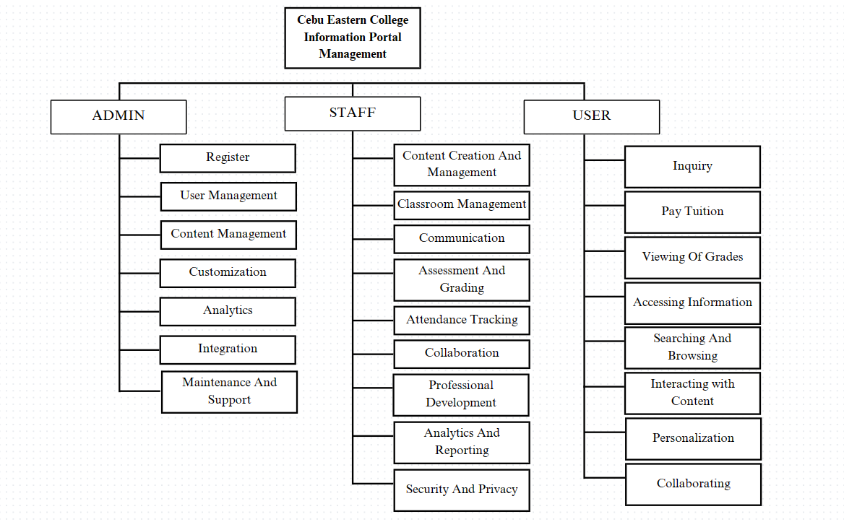

**USE CASE DIAGRAM**

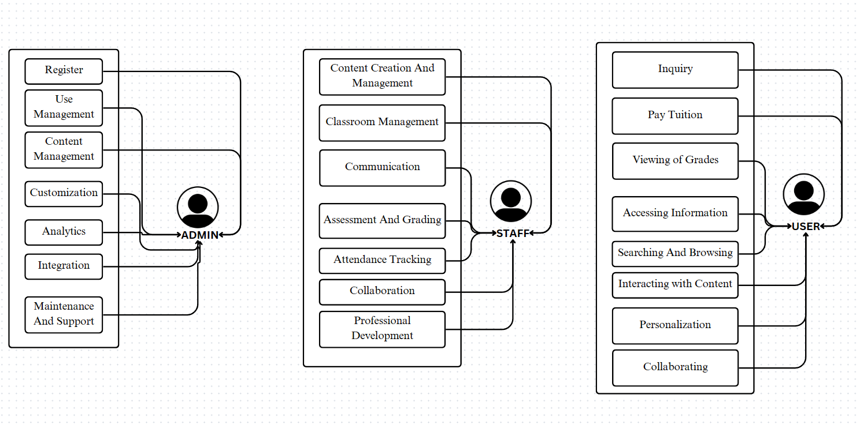

**UI OF CEBU EASTERN COLLEGE INFORMATION PORTAL MANAGEMENT**

